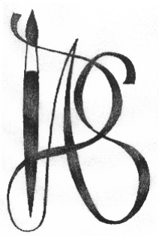 | Denbighshire Art Society  COLWYN BAY  10 Penrhos Road  Colwyn Bay  Conwy  LL28 4DB  http://www.dasoc.info

APPLICATION FOR MEMBERSHIP

Thank you for your interest in joining the Denbighshire Art Society.

Our society was founded in 1940 and has its own studio where we have a programme of workshops, demonstrations and lectures.

The society meets most Saturdays between 2 and 4pm for demonstrations and 10am - 4pm for workshops. There are also interest groups arranged for landscape, life drawing, portrait and abstract art. There is a small cost for workshops on a Saturday.

We have exhibitions in the Spring and Summer and an Annual AGM.

In order to succeed as a society we need all members to contribute to keeping the studio clean, exhibiting their work helping with supervising exhibitions and the general running of the society.

ANNUAL MEMBERSHIP £45
Payment due on November 1st.

Please send your application form to THE MEMBERSHIP SECRETARY
At dhsmith355@hotmail.co.uk or the above address. Any enquiries please write to the above address.

I look forward to meeting you soon.

Gillian Snape
Membership Secretary

Denbighshire Art Society

COLWYN BAY

10 Penrhos Road

Colwyn Bay

Conwy

LL28 4DB

http://www.dasoc.info

APPLICATION FOR MEMBERSHIP

Mr/Mrs/Ms

Surname____________________ First name_____________

Address (Capitals please)

______________________________________

______________________________________

______________________________________

Post Code ___________________

Telephone Number ___________________

Email ___________________________________________

The society will keep your details for administrative purposes; record keeping; providing information and arranging activities which we may notify you from time to time. These particulars will not be disclosed to persons outside the Society’s committee.

Signature ______________________ Date ________________

